Click
https://ridbrprod.state-reg-eastern.tylerapp.com/portal/public
Click “Register an Account”
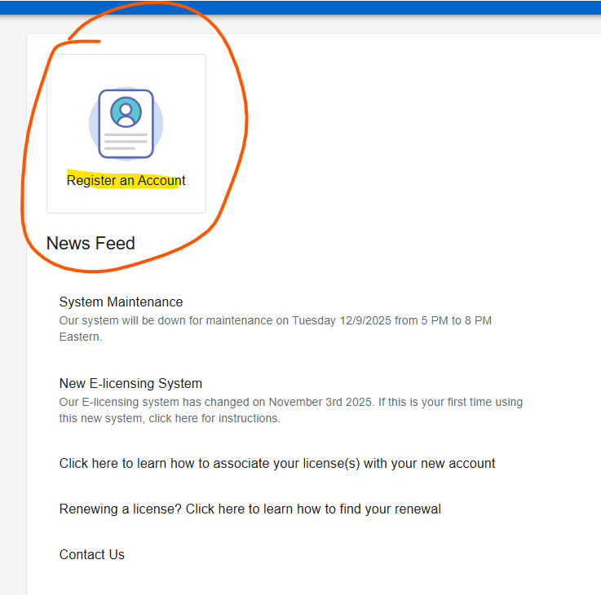

Click “Sign up”

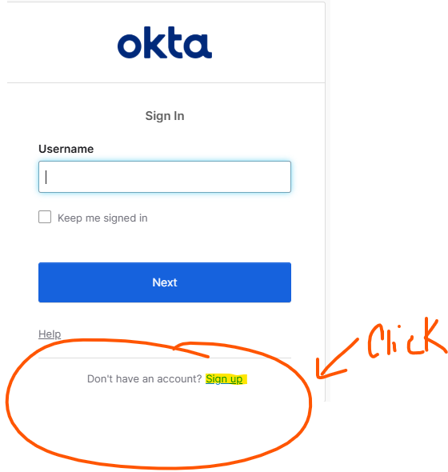
Enter your First Name, Last Name, Email Address
Click “Sign Up”

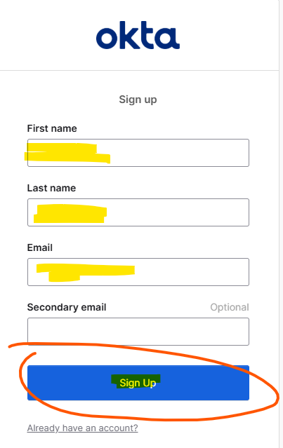
Click “Set up”

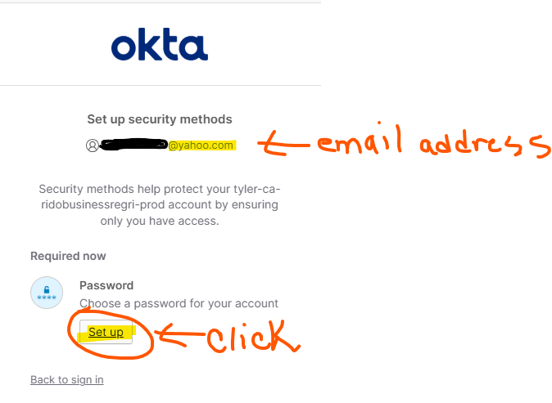
Enter “Password” – Re-enter “Password“
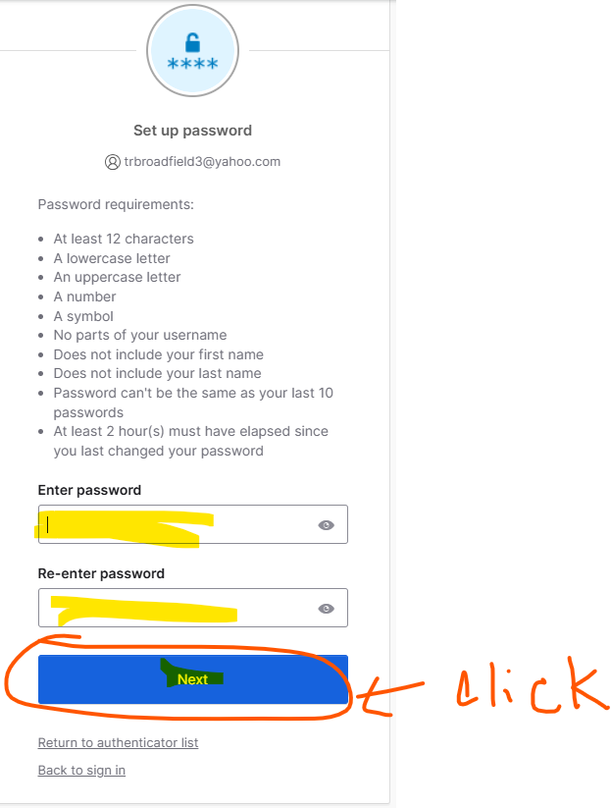

Open your email account that you entered, and enter code
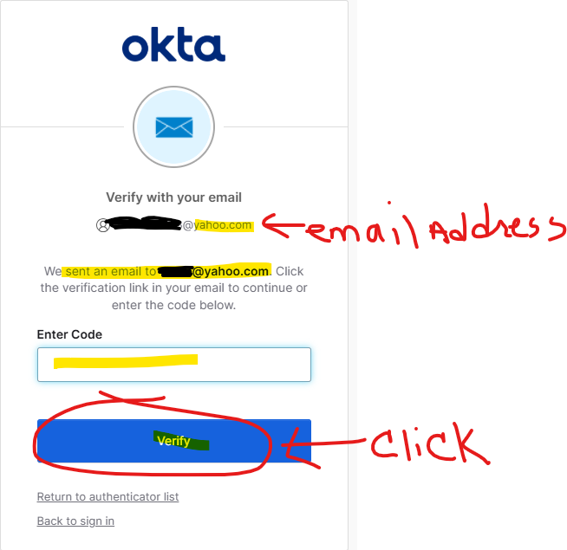
Click “Back to sign in”
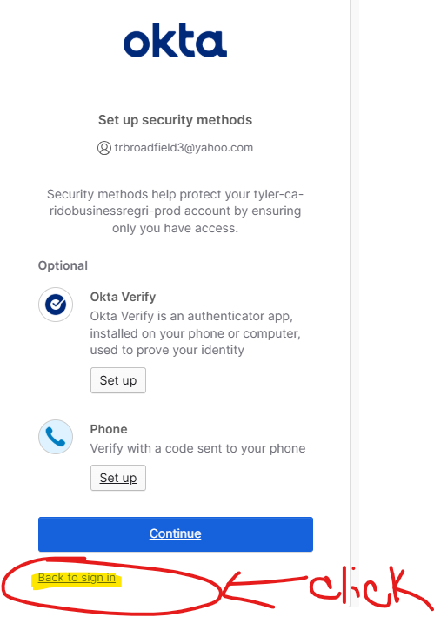
Click “Find My License”
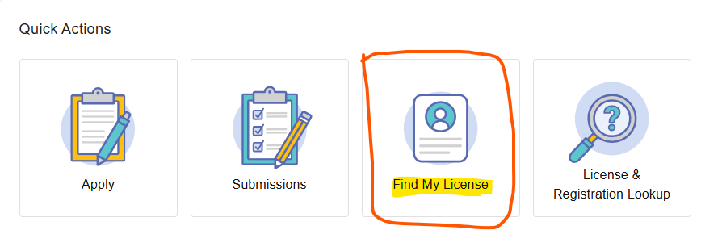
Click the “down arrow” on the right – selection “PE Certificate of Authorization” – Click “Next”
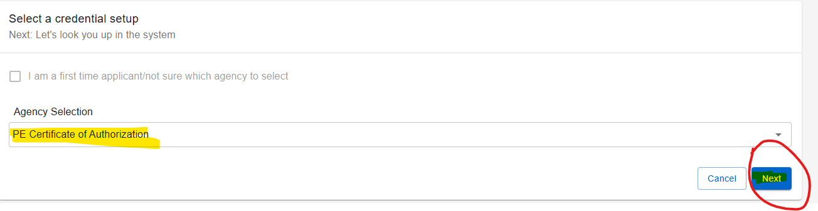
Click “Organization – Click “Next”
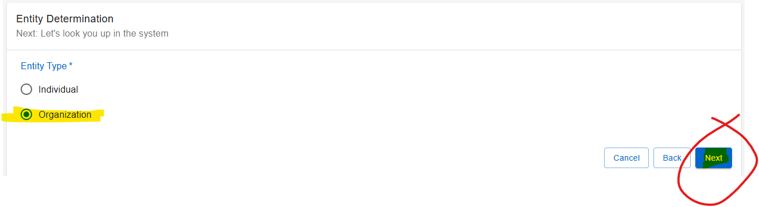

Enter “FEIN” and “Organization Name – Click “Next”

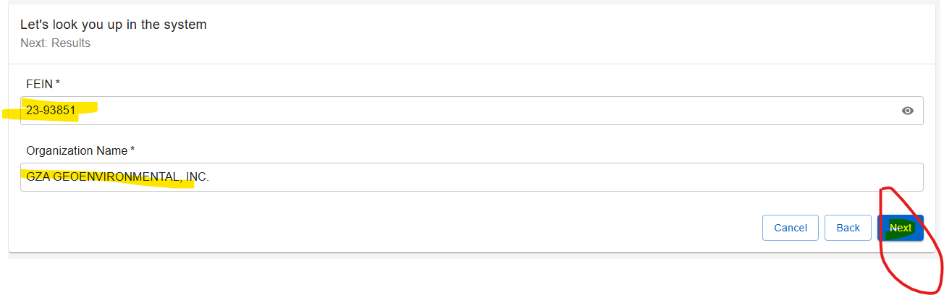

You will see the name and information. Click “Finish” in the lower right-hand corner.
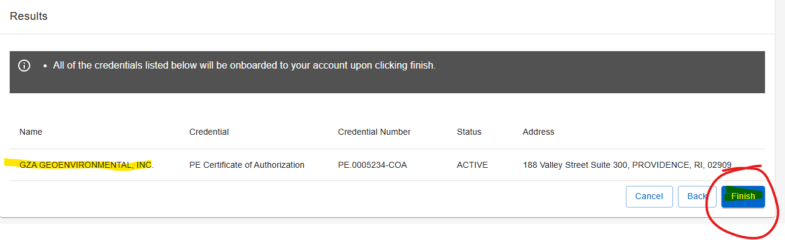

Click “Home” and get on the “Home” Page. - In the left corner – in the blue strip – on the side of your name – you will see 3 lines (also known as the hamburger icon) – click it.
Click “Home”
Click the “Apply” Title
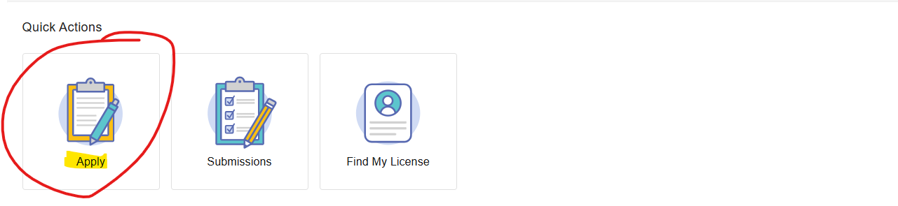

Select “Board” – “License Type” – “Application Type” – Click “Search” – Click “Start”
