https://ridbrprod.state-reg-eastern.tylerapp.com/portal/public
Click “Register an Account”
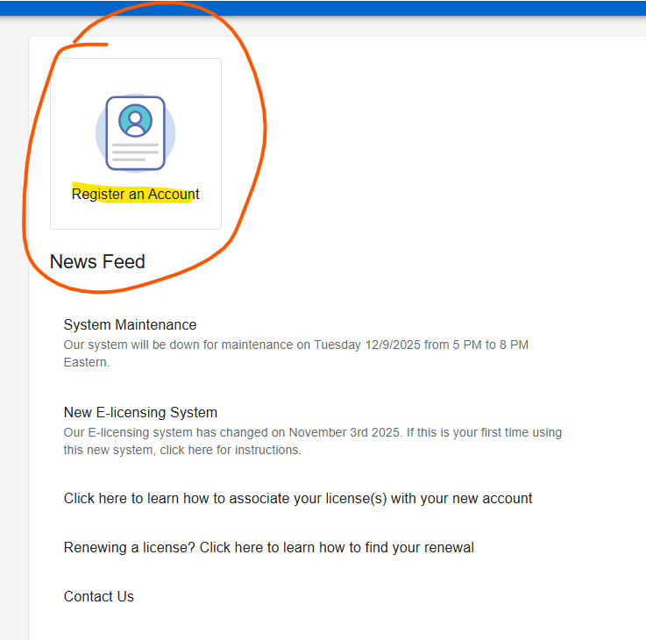
Click “Sign up”

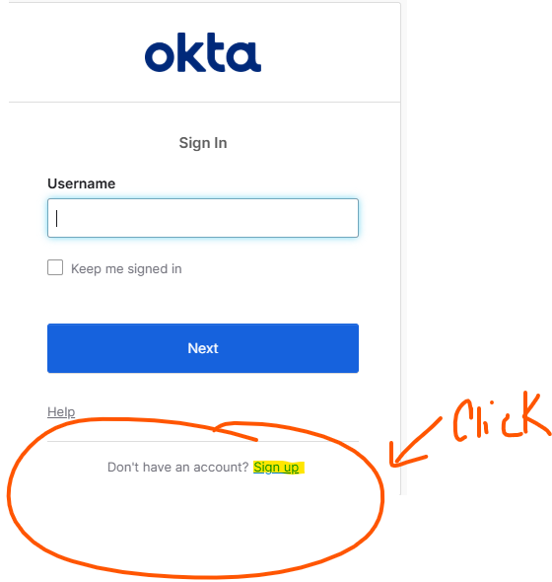
Enter your First Name, Last Name, Email Address
Click “Sign Up”
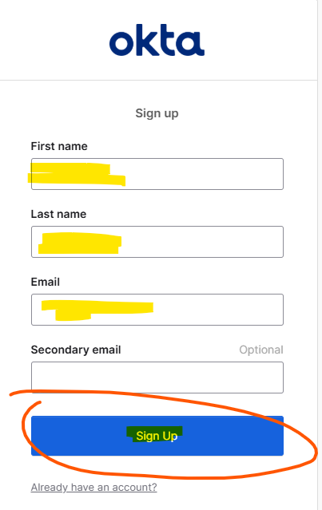
Click “Set up”

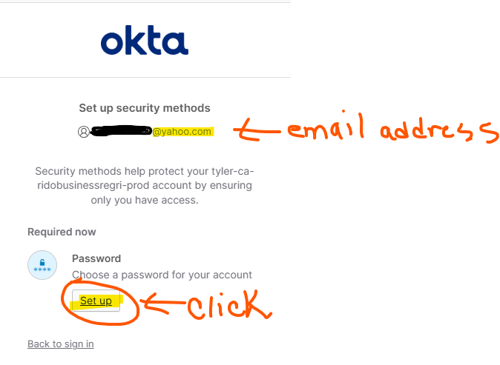
Enter “Password” – Re-enter “Password“
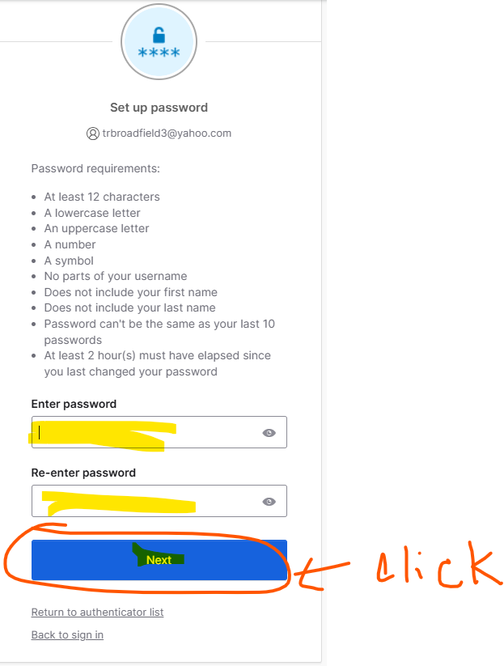

Open your email account that you entered, and enter code
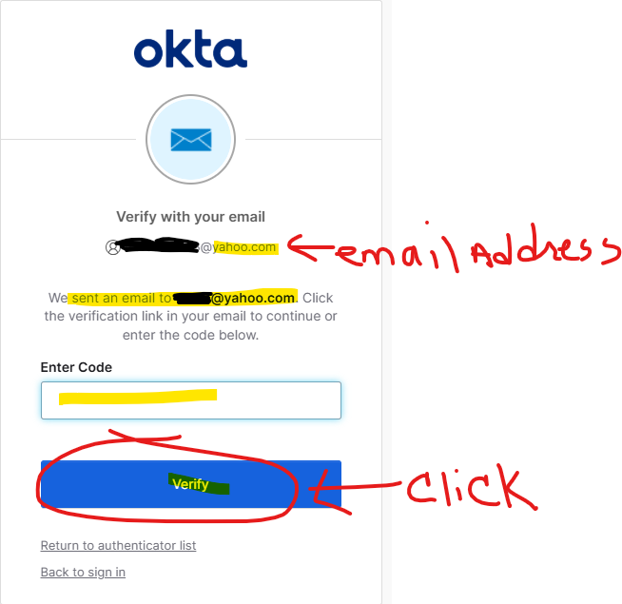
Click “Back to sign in”
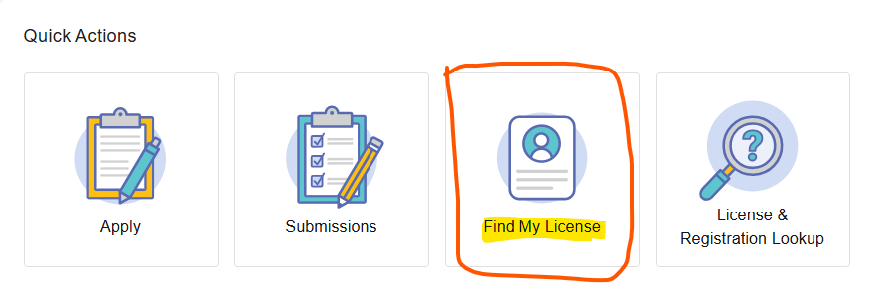
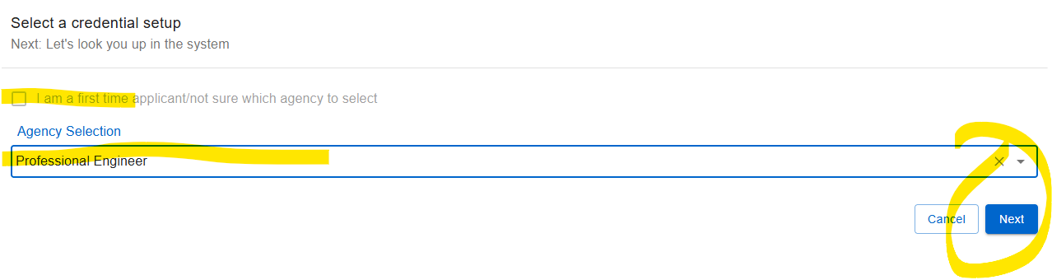
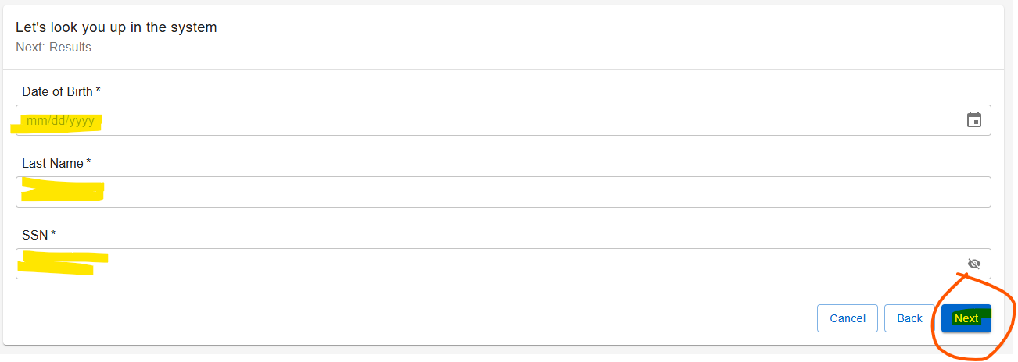
You will see your name and information. Click “Finish” in the lower right-hand corner.
Click “Proceed” to Home Page.

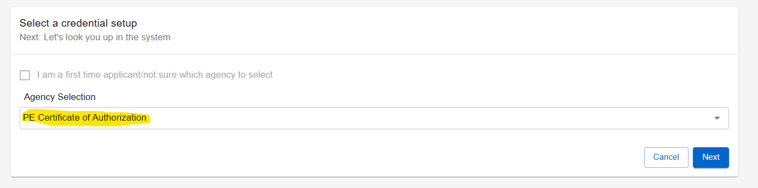
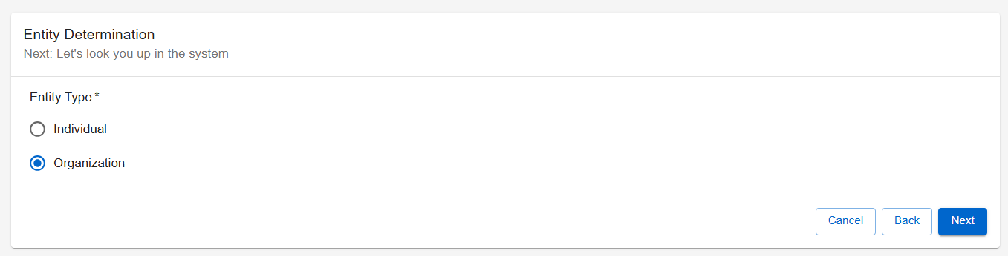
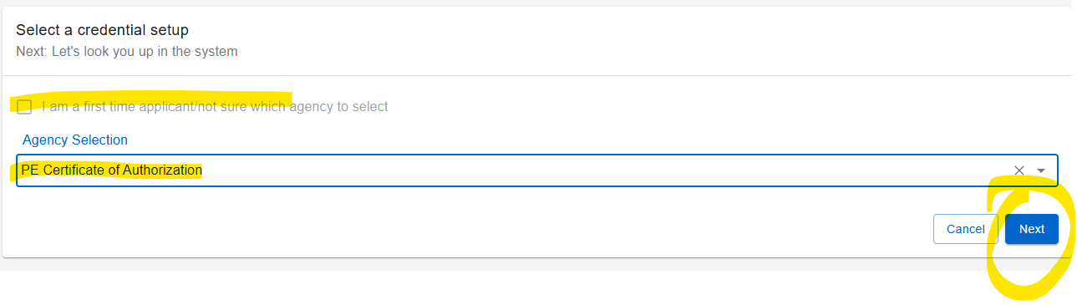

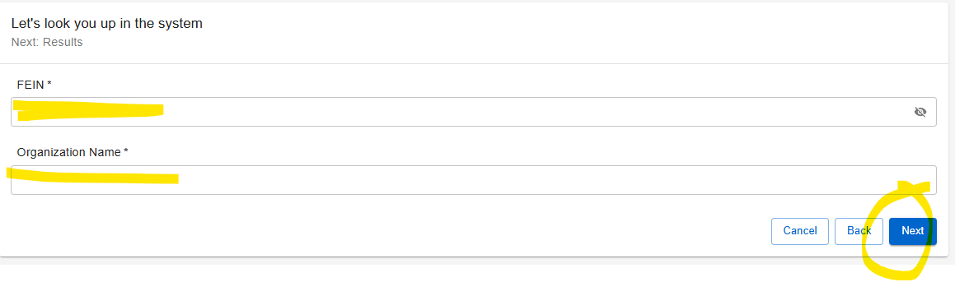
You will see the name of the firm. Click “Finish” in the lower right-hand corner.

Click “Proceed” to Home Page.

Click the title “Attention Needed” - Renewal Urgent – to complete your renewal.

